**Elaborate:**

|  |  |
| --- | --- |
| Natural Greenhouse Gas | Grade 10 Science – Earth and Space Science |
| Handout | |

View the *1B Grade 8 Water Treatment Process Ozobot Evo Explain and Elaborate* PowerPoint to assist in creating the Water Treatment Process Ozobot map



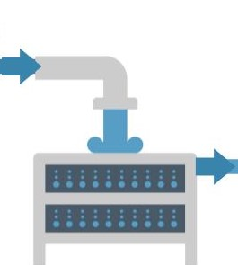Provide Explanations for each stage of treatment:

 